**Corner Grocer Produce Frequency**

With this code, it’s personally easier to start simple and work from there, starting with the displaying the initial menu of choices the user has to select from. Then work up and get the desired menu selections, creating an initial structure, before working on the necessary class functions. After that, then moving on to create the meat of the program inside the class working with each desired menu option.

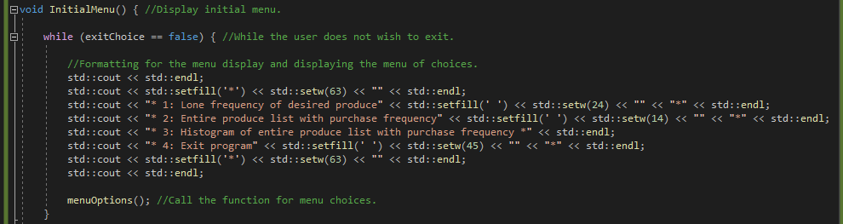

Starting with the initial menu display to create a desirable and readable list of menu options to choice from, before moving on to asking for which option the user would like to select.

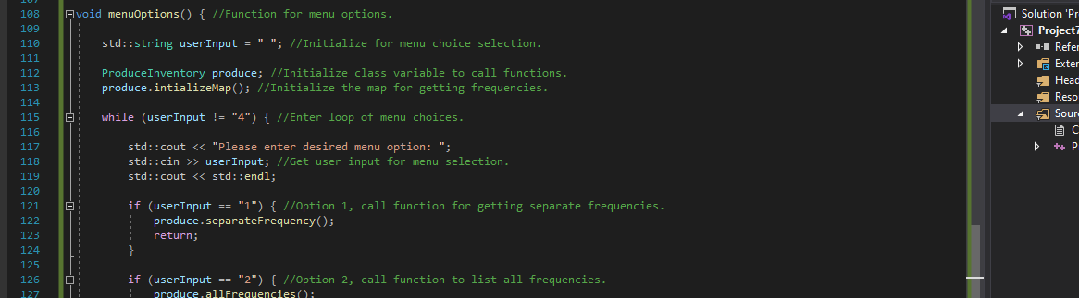

Making sure to keep not only the code readable, but also the display that the user will be reading as well. Then move onto the class to go through each desired menu option with what the user desires to see, whether it be the individual frequencies or the entire list of frequencies from the input data, making sure to meet all of the desired initial functionality requirements set out by the Corner Grocer team for what they request for the final product.